**E-Project User Guide**

**Online Insurance**

**Group Members**

* Corunes Bhatti

ID: Student1399540

* Muhammad Shabbir

ID: Student1397587

* Usman Ali

ID: Student1399280

* Asad Ullah

ID: Student1396409

* Hafiz Muhammad Sameed

ID: Student1398528

**Faculty Members**

**Teacher: Miss Neha Shah**

**Coordinator: Miss Fiza Arif**

**Table of Contents**

E- project………………………………………………………1

Group intro……………………………………………………2

Table of content……………………………………………….3

Acknowledgment……………………………………………..4

Screenshot………………………….………….………………5

Conclusion…………………………………………………...16

**ACKNOWLEDGEMENT**

We are deeply grateful to the **Almighty Allah**, for His blessings and guidance, which have enabled us to successfully complete our **E Project of online insurance**. We have made every effort to consider all relevant and important topics in the development of this project, aiming to make it comprehensive and valuable.

We would like to extend our heartfelt appreciation and thanks to all the individuals who have played a crucial role in our journey towards project completion. Without the support of these individuals, our achievement would not have been possible.

We would like to express our sincere gratitude to our dedicated faculty member, **Miss Neha Shah**, and our coordinator, **Miss Fiza Arif**. Their unwavering support, guidance, continuous encouragement, and supervision throughout the course of this project have been invaluable. We consider ourselves fortunate to have had the opportunity to work under the tutelage of such a supportive and cooperative teacher and coordinator.

**Screenshots**

***Add Policy View:***

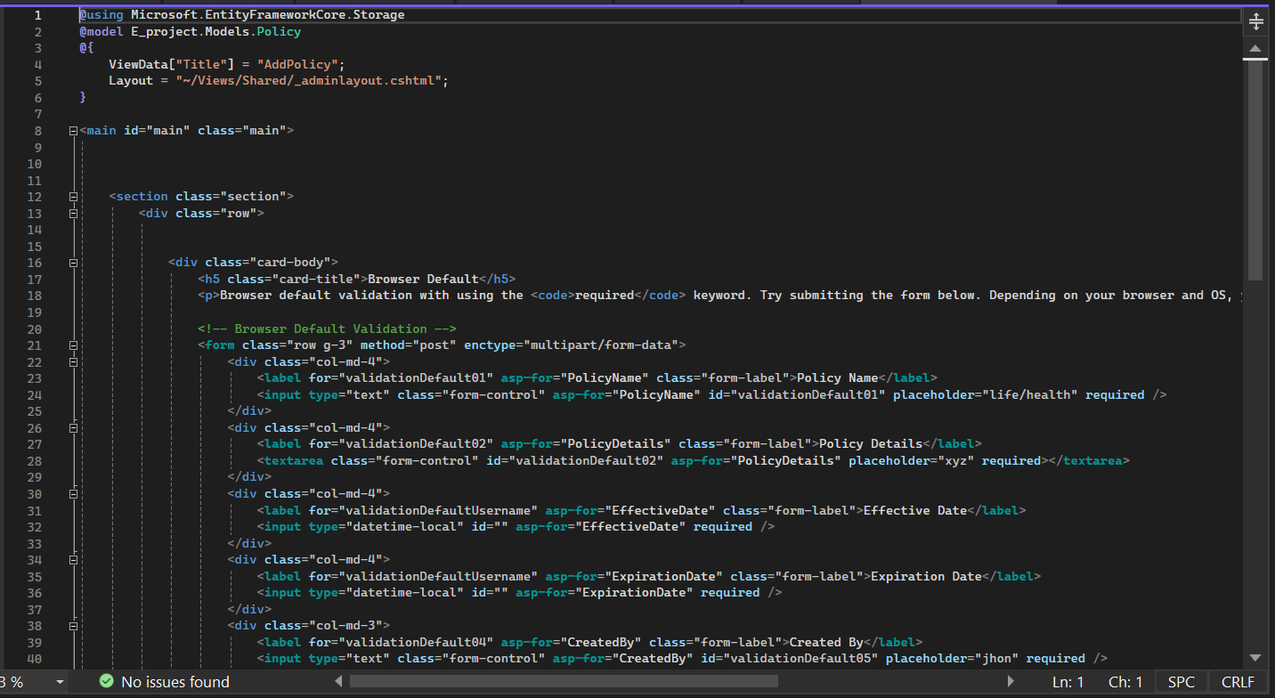

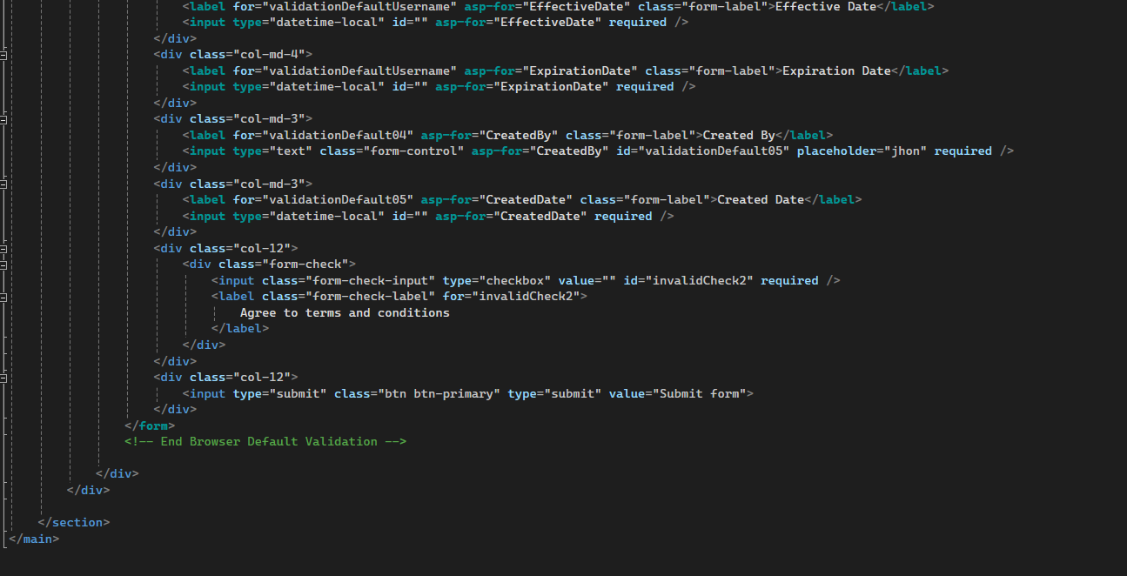

***Policy View:***

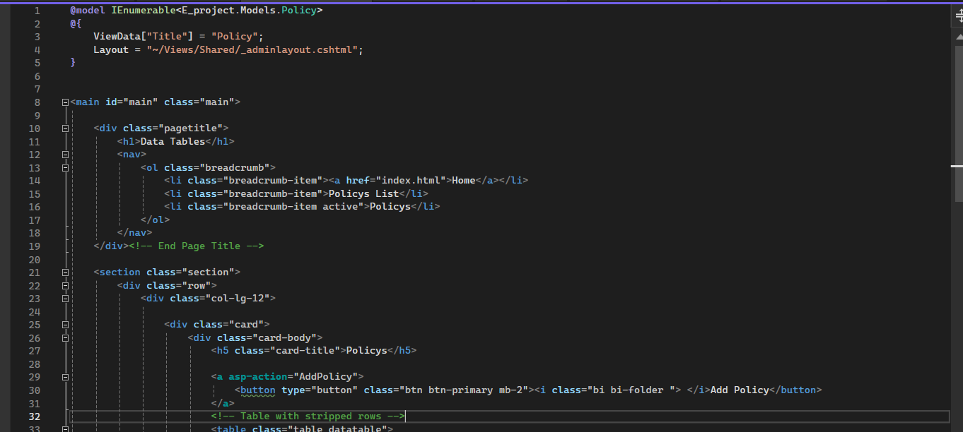

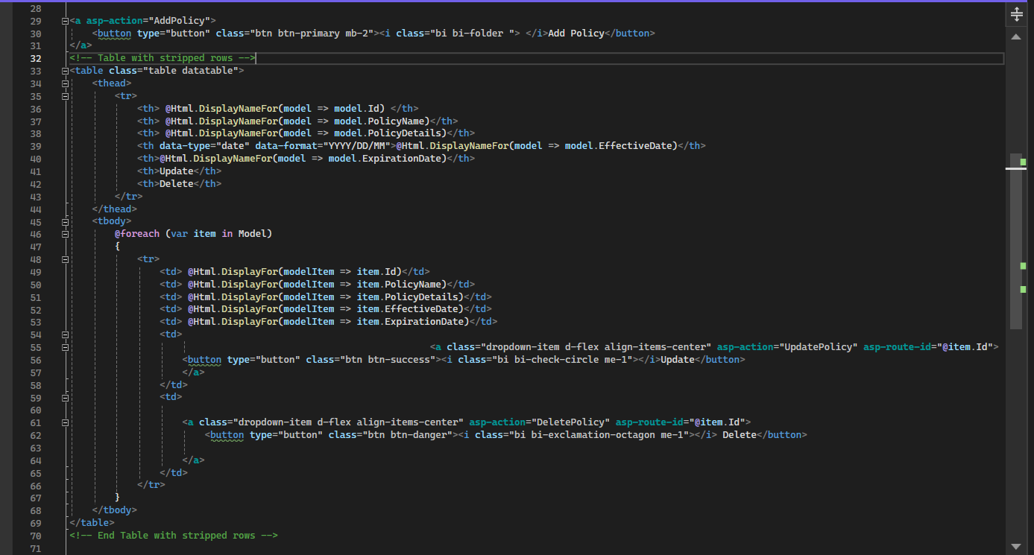

***Delete Policy View:***

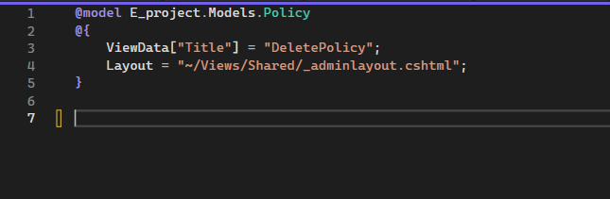

***Policy Add Or Show Controller:***

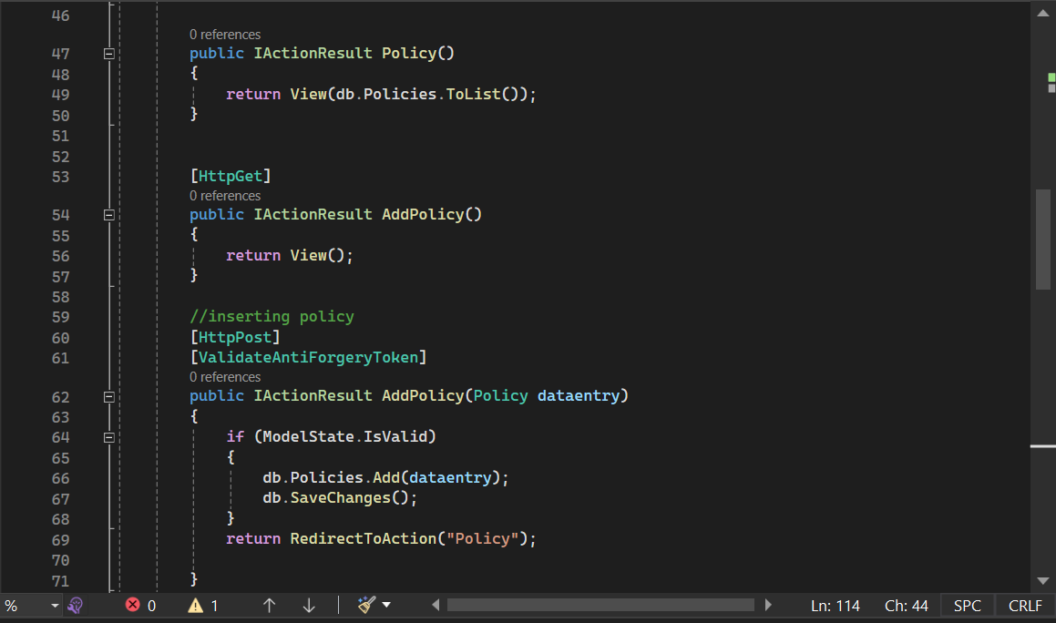

***Policy Delete Controller:***

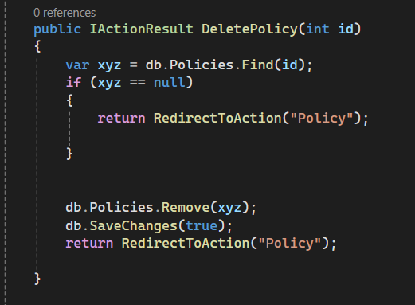

***Policy Model:***

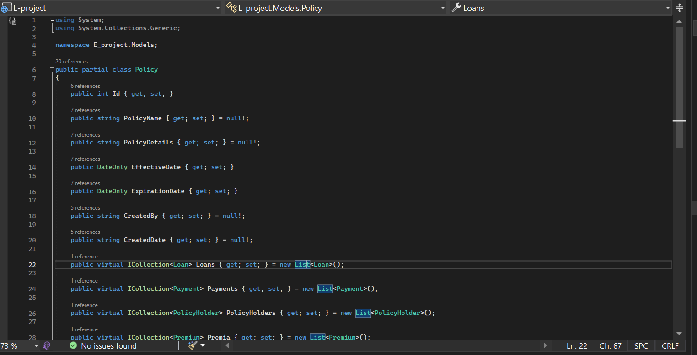

***Policy Update Controller:***

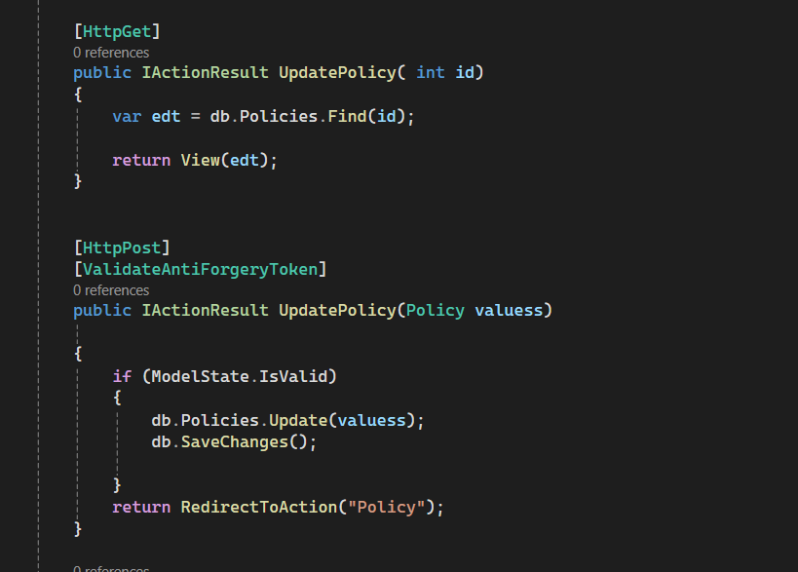

***User List Show Controller:***

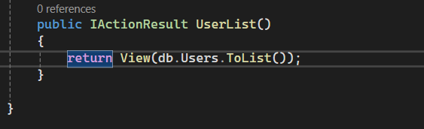  
  
***User List View:***

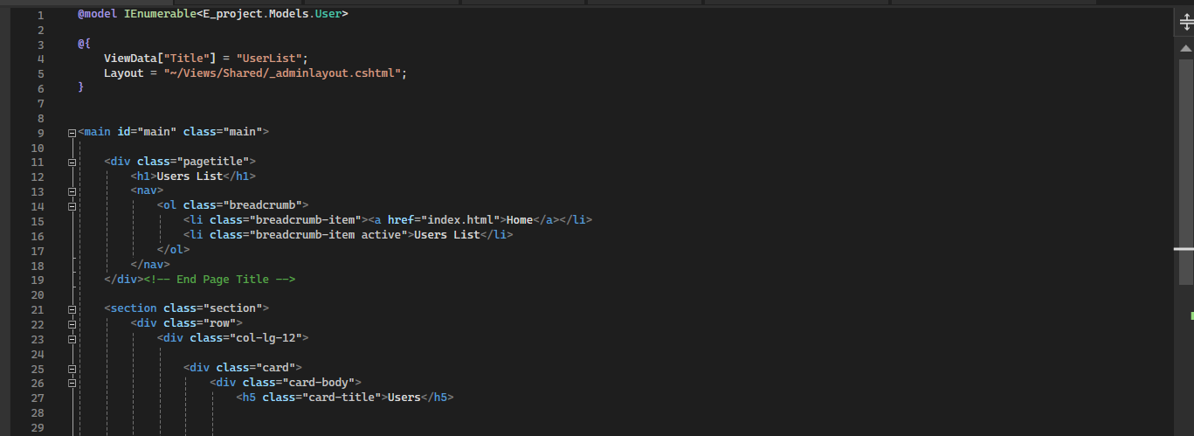

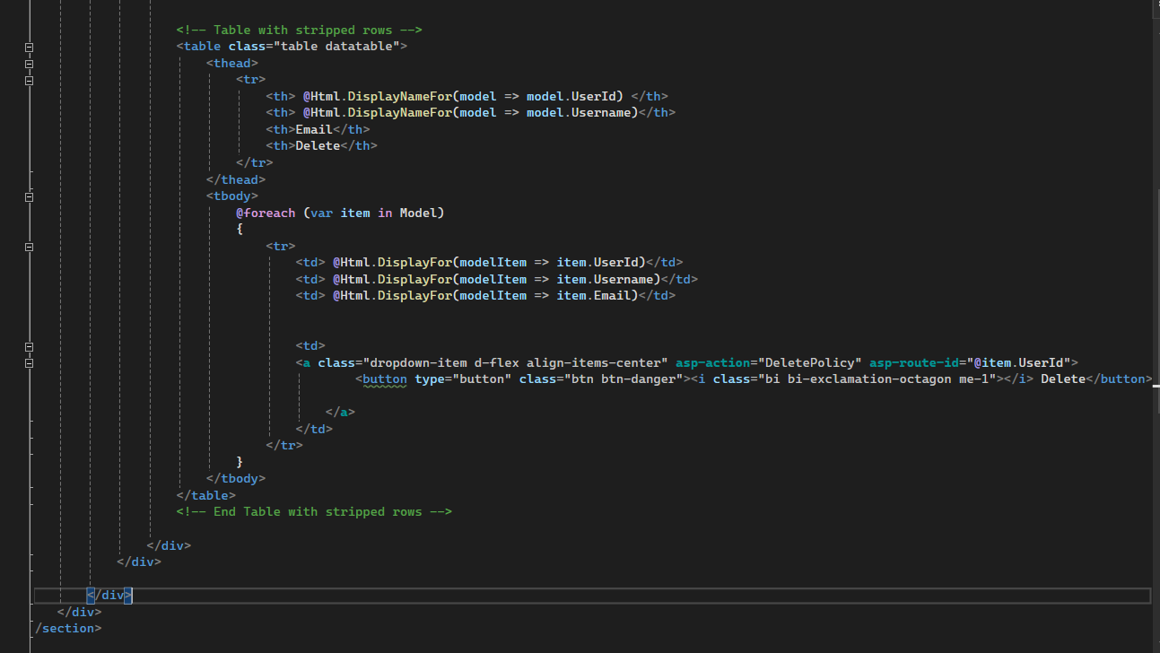

***User Model:***

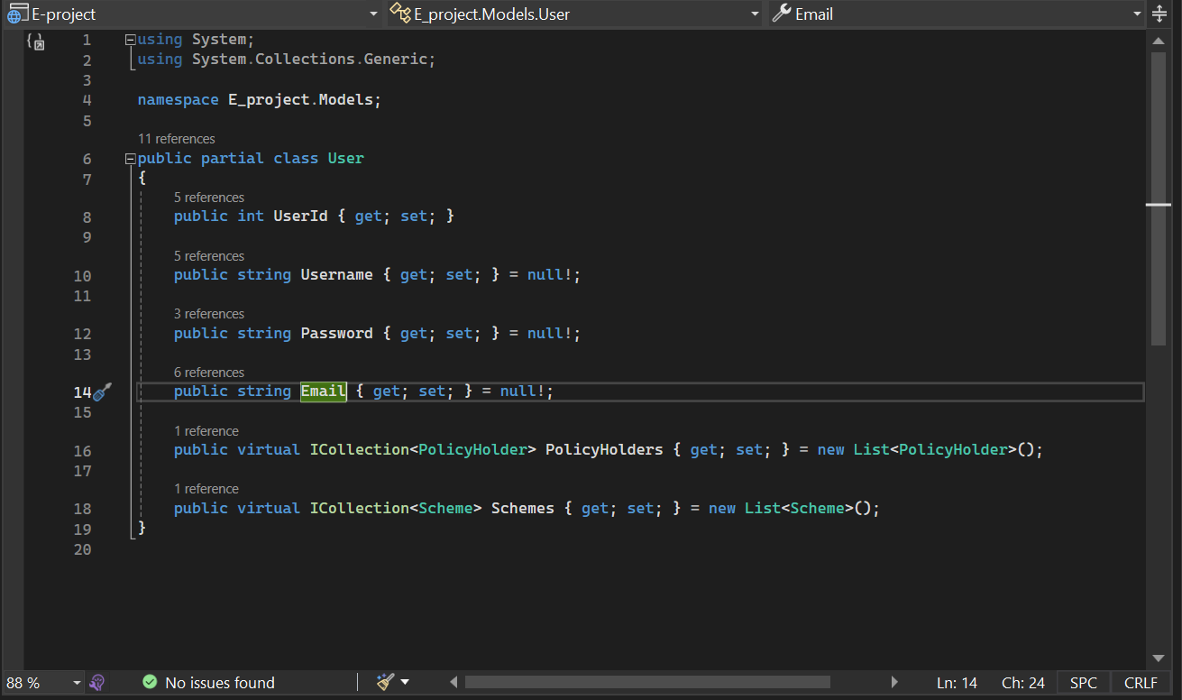

**Conclusion:**

In wrapping up, completing our online insurance project is a big deal. We wanted to make sure people could easily get insurance online, covering things like life, health, car, and home insurance.

Big thanks to our teacher, **Miss Neha Shah**, and coordinator, **Miss Fiza Arif**, for their support.

Our solution has cool features like a database, automatic ID creation, and easy searching. It's designed to make insurance stuff simpler and quicker for everyone involved.

We made sure our project works well with standard computers and software, so it's easy for people to use.

Overall, we're proud of what we've done. This project should make getting insurance online easier for people, and that's pretty awesome. Thanks to everyone who helped make it happen!

**Thank You**